Design Document - Enter Key

**May 18, 2018**

**OBJECTIVE**

To give users the ability to hit enter after putting a search keyword into the search box.

**BACKGROUND**

Jammming utilizes the Spotify API to allow users to search the whole Spotify library of artists, albums or songs. They can then save any of these to a playlist which can be saved to a user account on Spotify.

The tool has the following capabilities:

1. Enter a search term into the search box
2. Presents a list of tracks
3. Add a track to a  new Playlist
4. Rename the Playlist
5. Remove a track from a Playlist
6. Connect to Spotify and Detect Login Status and then either allow the user to login or recognize that they are already logged in.
7. Save the Playlist to Spotify

Our goal with this feature was to create an MVP of a Playlist maker which could later be expanded with additional features providing more playlists, recommendations and a shinier UI.

**TECHNICAL DESIGN**

When a user enters a search, they can only complete the search by clicking the “Search” button with their mouse. We want our users to be able to also hit “Enter” to perform a search.

We will utilize the “onKeyPress” event as it works for all browsers and has an event order of:

1. onkeydown
2. onkeypress
3. onkeyup

Which could be used to expand the functionality of the tool down the line.

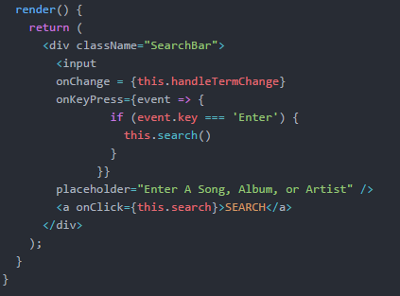

In addition, we want the user to receive feedback that the pressing Enter has done something (outside of just presenting the tracks) so we will add the same hover/click state indicator on the “Search” button by:

1. Setting a local state boolean variable to true
2. Use the local state to enable/disable the class
3. Set a timeout to set the variable back to false.

|  |  |
| --- | --- |
| **Normal State** | **On “Enter” (ignore the pointer)** |
| https://lh6.googleusercontent.com/pK1PPXEWJ7_-QYmbTgINwV3hxcioBcvHs9Q9VVVVLRumwYJ9viDNvi8ywApCAjtSWEOpdO4pDT64YWEbvfRMXtbQeuiypAJzpxHoYiwgQuGcZTuw-Ev8pPb9Vm4OrlEn2bdGGuoh | https://lh4.googleusercontent.com/uGc72HPaQ8lZdO3S-67GLnjXtnxzgHZnkbhrg0QLWbFV7n5sDh3vggBJVey2WbZ60fs2Qcz-6IPgP7_z7ktLzg3cOwXrIY_JoSSDTRtMSgHR2afTMEqxnR7ty-FFbnzcPBMofm9L |

**CAVEATS**

The only caveat to the current implementation is that it does not assume or recognize any other types of ways that a user might indicate to the Search Box that they are complete with entering their search, i.e. hitting Space or Tab.

There is likely an alternative solution that recognizes more key presses and could accommodate a wider range of user interests which could be switched to down the line if required.

This solution also suffers from being specific to 1 button/action by the user and will not cover a user hitting enter when they rename a playlist. That feature will have to be implemented separately.